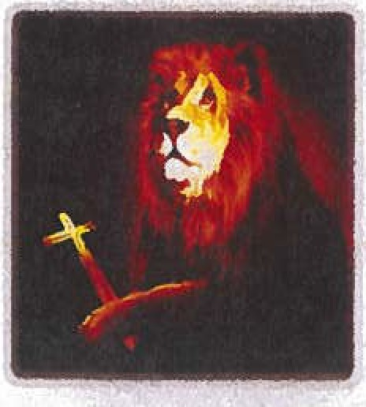

**tH;bt 1Lton''ilBtn**

Sa.int Leo Magnus Parish Sesquicentennial Monthlg Newsletter

1874 *"'Bui{c[ing (joas 'Design in 'Unity for 150 Years!"* 2024

NUMBfR7

111Depot Street + RidgwalJ + PennslJlvania + 15853

AUGUST 2024

. . . . . *...fll pao*

+ *The Stone which the 'Builders 'Rej.ectecf lias 'Become the Cornerstone* +

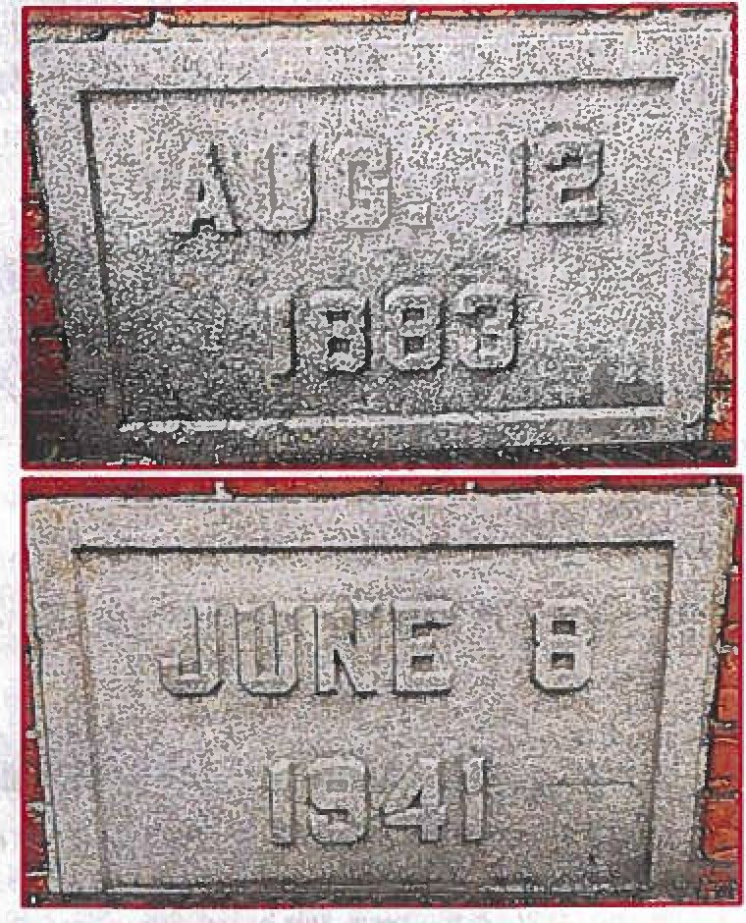

#### 141gears since the laging 0£ the cornerstone 0£ the second Saint Leo Magnus Church

This summer marks signilicant moments in thehistorq 0£ our parish, namely the laying andblessing 0£ the cornerstones 0£ the second church (1883) and the present edi£ice (1941). This month we will be removing the two cornerstones located in the £ront exterior walls 0£ the church to £ind the two time capsules sealed there in 1941. We will display their contents and then begin to foshion a new time capsule for this anniversarq year. All three

capsules will be re-buried in November at the cemeterq. STAYTUNED!

*'Topreserve antlpromote Jlistory, 1feritlllJe, 1founessl*

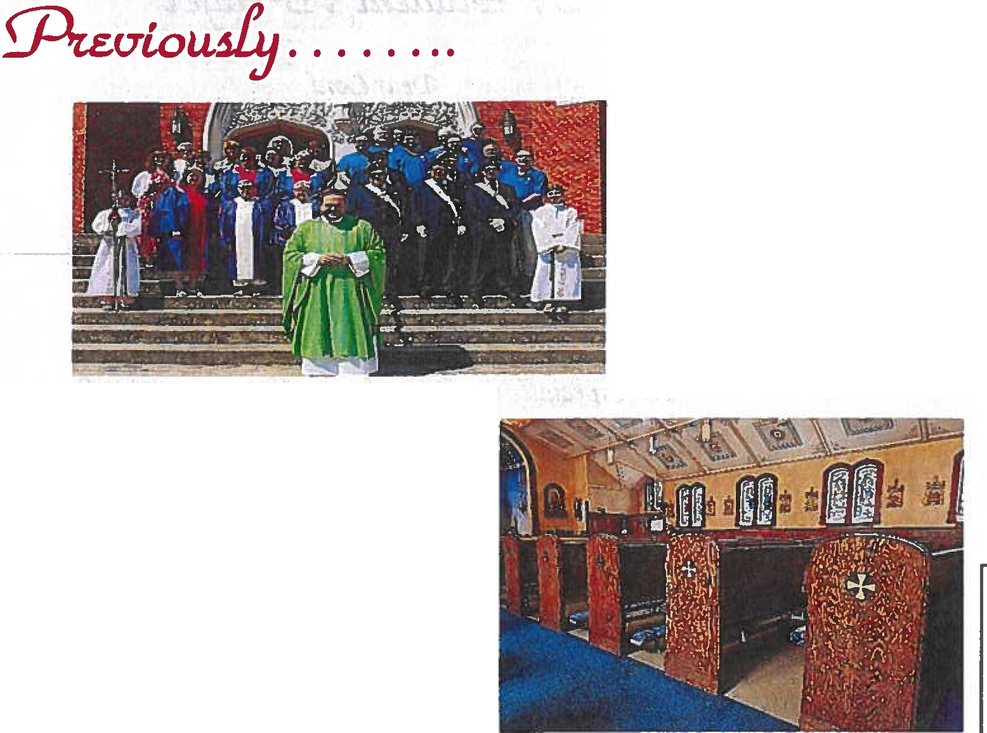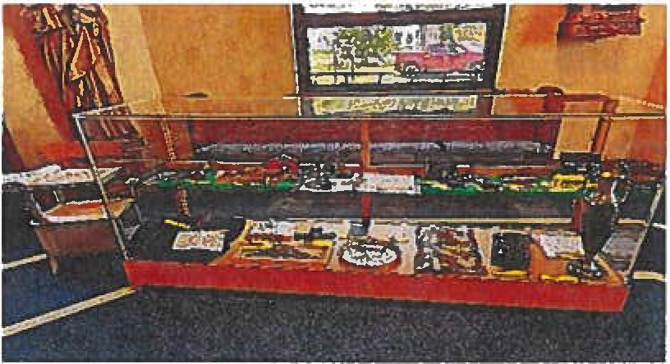

j HISTORY BEFORE OUR

EYES - *Father Justin prepared the long­ empty disp"9 cases in the Gathering Space with numerous historical artifacts honoring the past 150years of our parish story. Stop by*

*and enjoy. Bringyour treasures to add!*

j

APPRECIATION

FOR

SERVICE - *On Sund, Jufy 28, members of the Knights of Columbus and Catholic Daughters ofAmerica were honored at mass with a special blessing written by our*

*pastor, Father Justin.*

+- ACCENTUATE

THE

POSSIBILITIES! -*Local artist, Nanry*

*Tomaski, began accented a number the cross motifs on the pews and above the windows in church inpreparation far our anniversary mass*

*of thanksgiving in November. Keepyour ryes peeled, there's more to come!*

*150 <]fui.u.* ..*.150* dl:otla.

*Each month we lllill share ten Ii/liefacts about the history of ourparish. If you have a'!)' memories or inlen:sting facts, please call Father Justin (814.772.3135). Let the countdawn begin!*

#SQ Jc.eph Alcua Wdll assistant priest here from 1974-1976; and

Marlin l<repdio Wdll assistant from 1976-1978.

*#88:* Jc.eph Caarkowalct was assistant priest here from 1978-1980;and Stanle1:1 Swe.dae. was assistant from 1979-1982.

#87: Ronald Toven was weekend assistant here from 1980-1982; and Jamee McCormtck was assistant from 1982-1982.

#M Chrutopher Hamlett Wdll weekend assistant here from 1982- 1982;and Mark Bartdaak was assistant from 1982-1986.

#ft} Joeaph KaltnCJWBki was weekend assistant here from 1982-1994, and Stephen Anderson was assistant from 198.5-1987.

#84 Thomu Suppa was assistant priest here from 1986-1988; and Theodore Marconi WdS assistant from 1989-1988.

#M Willtam Luka was assistant priest here from 1988-1989; and Willtam Sutherland was weekend assistant from 1989-1992.

#82: Paul Siebert was assistant priest here from 1992-1994, and

Ce.almir Bognte.k was assistant from 1995-1995.

#81: Robert Horgaa was assistant priest here from 1995-2001; and Jamee Faluacr.ak was resident from 1997-2001.

#80: Dilworth "Skip" De.via was assistant priest here from 2001-2005; and Jc.eph Reigel was resident from 2002-2003.

*fPope.*_.&, dpe.ak *d/-9aln*

*In thepast 2,000years of the Catholic Church* - *we have had thirteenpopes*

*who have been called Leo. Thefirst* - *Pope Leo the Great* - *is ourparish patron. The last, Pope Leo XIII reignedfrom 1878 until his death at age*

*93 in 1903. Each month we will ihare images of theie two important*

*shepherds and quotesfrom theirprolific writings.*

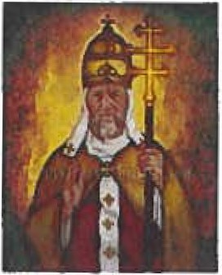 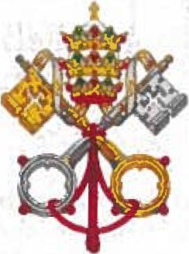 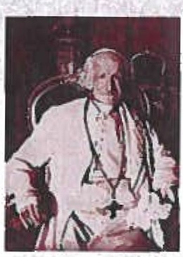

''Peo.ce isthe £irst thing the ongels song. Peo.ce isthe mark 0£ the drllc:lren 0£ God. Peo.ce isthe nurse 0£ love. Peo.ce is the mother 0£ unihj. Peo.ce is the rest o£ the blessed. souls. Peo.ce isthe dwelling plAce 0£ etemihj."

- *Saint Leo MagnHS*

'ihe Church isthe sureguide And teo.cher 0£ the truth.. The Church ksthe right tospeo.k out on mAttera 0£ justice And moralihj. The Church condemns ell£orms 0£ violence And injustice. The Church promotes peo.ce And harmon1;1 Among n4tions. The Church de£ends the dignihj 0£ eYef1:J humAD person. The Church upholds the sa.ndihj 0£ li£e £rom oonception to DAturaJ deo.tJi."

- *Pope Leo XIII*



POOKET DIOTION.A.RY

or TD•

ENGLISII LANGUAGE:



TIO .WUIO DlOl'IOXA&Y 01'

NOAH WEDSTER, LL.D..

WILi.iA){ O. WBBSTBR WILLIA)( A. WHEELER.

*In 1921, Frederick Barnard famousfy quipped· '.'..4 picture is worth a thousand words." However, words* - *and their meanings* - *often change throughout lime. Each month we will look at some words as they were defined in 1874* -*theyear our parish was <?fficialfy eitablished*



*1!J the Biihop of Erie. These*

LET US PRAY: *A Month!J Offering From Our Heatts*



*©earLord,*

*Jlefp me to 6e tlie 6est stuaent Ican 6e. Jlefp to stuay wefl an4to stwfy often,*

..........

,,. n.. *n-bfltl -.....*

*definitions are taken from '.'..4*

*Pocket Dictionary of the English*

*especialfy wlien*

*I tfon*

*'tfee{ CistutfyitllJ at al!*

NEW TORJC1

lVIsoN, Bl.AKBHAN, TAYLOR. • CO.

--·ct.•o.•-"'-

117.. J

*Webster & William A. Wheeler, the title page of which is at left.*

*Jlefp me to listen to my teacliers antimy coaclies.*

###### *Jlefp me top fayfai r an4topfay safefy. Jlefp me to 6e ijn4to everyone at sclioo{*

Man'ilcin, *n.* A little man; a dwarf; a model 0£ a.

man.

Man'..-0£....war, *n.* A war vessel.

Milch, *a.*Giving milk

Mote, *n.*A vef1:J small particle.

MlJrrh *n.*An inspissated [thick/dl'l:J ]sap in drops.

*an4especiafly to tliose w6om otliers treat unijndfJ. Jlefp me to treat otliers as I woulif Ci tliem to treat me.*

*Jlefp me to 6e a 9ootffrien" to otliers.*

###### *Jlefp me to 6efp ot6ers wlio neetf my 6efp. Jlefp me to tfo tlie 6est 'WO'l(I can tfo.*

*Jlefp me to use aflt6eIJfitsyou liaw IJiven me.*

###### *Jlefp me to fove an4respect my parents.*

*Jlefp me to trust inyou, Lord, an4inyour fove for me.*

*Jlefp me, Lortf, I neetf you/*

*)f.men.*

*f o't the a'lttonorr,Lu*

*Saint Leo Parishionerr recall thepast of ourpansh* '.r *story*

Of the man'! aasistant priests ln the pe.at 00 IJeaP, one servant of the altar of ten comes up ln conversation wlth older parishioners -father

'Jfz;,rr,l:e.uz, *t!cwz.J:W.* -*<.One !Body ln Ch, ,rr,W;*

*Let us t?member the People of God throughout the Diocese of Erie as thry celebrate theirparish* '.r*feast dl!J this month.*

George Htdm9. Here'san lm48e and brief artidefrom the Lake Shore Visltor (MalJ Z>, 194!'.>)in the dosing dalJ of World War 11

Mass Said in Shadow of B-29

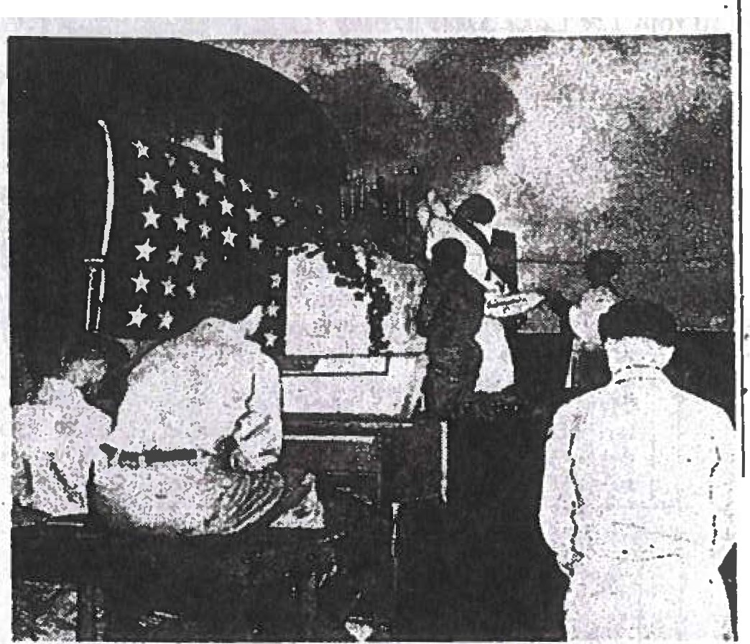

"Maaa at dawn" on Easter Sun- Father Hickey, a native of St. Pat. day before the nose of a B-29 at rick'• In Erle and former assistant

. M . at St. Leo's, Rldsway, has been at the ar.my air base In the ar1anaa the SuperfortrelS base on Saipan

of the 600th bombardment group 8ince Its capture by the U. S. At la pictured at the elevation of the the Easter MaMea the boys do­ chalice with the Rev. Georse Ill. nated $3.000 as their: Peter•a Pence

Hickey,. Erie prieat, .aa celebrant.' offering to th.e Holy Father.

.

Aug.2-

Aug.8 - Aug.10- Aug.15- Aug.16- Aug.20- Aug.22- Aug.24- Aug.28-

St.Eusebius: East Brady

St.Dominic: Sigel

St. Lawrence: Albion

Assumption 0£ the BVM Sykesville

St.Stephen 0£ Hungal'l_J: Erie, Sloa.ndale St. Bernard: Bradford, Falls Creek Queen 0£ the World: St.Mal'l_J 's

St.Bartholomew: Sharpsville St.Augustine: Austin



*Uf ulea.at ln Paae*

*rdainl...£w* a'lttmu *Pa'tW'z.*

+ + + + +

*!B§oJ 'h n. fn f 01i 150 !JUl.Uf*

WEARE A COMMUNITY Of BELIEVfRS JOYPULLY PROClAIMING, SHARING, AND WITNESSING 11iEGOSPPLMESSAGE Of JESUS CHRJSTHERE IN TiiE HEART Of fill( COUNTY SINCE1874.

*Please t?member inyour prl!Jers the souls of all the dead, in particular these below listed priests who served the Diocese of Erie, and whose death anniversaries are recalled this month of*AUGUST -

I ·Rev. Richard F. Tellers (1993)

I ·Rev. Matthew J. Ruyechan (2023) 2 • Rev. Patrick Smith ( 1888)

2·Rev. U:o D. Foley (1961)

2 ·Most Rev. John F. Whealon (1991 ) 4 • Rev. Peter J. Donahue ( 1941)

1. ·Rev. James J. Carpenter (1921)
2. • Rev. Kiernan O'Brannigan ( 1888) 7 • Rev. James Brennan (190I)
3. ·Rev. Joseph B. Keegan (1914) 7 • Rev. Francis S. Doyle ( 195 I ) 8 ·Msgr. Terence Brady (1940)
4. ·Rev. James J. O'Keefe (1872) I 0 • Rev. Philip Karolick ( 1989)

10·Msgr. Edward H. Latimer (2000) 11 • Rev. David Snively ( 1868)

11 ·Rev. Joseph Vacanti (1939)

11 • Msgr. Daniel Fitz.patrick ( 1949) 12 • Deacon Richard A. Reed (2022) 12 ·Rev.William Norton (1885)

14 ·Rev John F. Donnellan (1915) 14 ·Msgr. Bernard Kloecker (1914) 14 ·Rev.Joseph Barry (1964)

*I S ·*Rev. George Meyer (1911 )

IS • Rev. Thaddeus Napieralski ( 1942) 15 ·Rev. Bernard F Webber (1996)

16 • Rev John Galligan ( 1896)

1. ·Rev.Thomas Cavanaugh (1922) 18 • Msgr. Edward Zeitler (2017)
2. ·Msgr. Wilfrid *J* Nash (1992) 21 ·Rev. John S.Garman (1949) 22 • Rev Rocco A.Tito (2022)

22 ·Rev. Farrell Briody (1902)

1. ·Rev. T Maunce O'Hern (1936) 22 ·Msgr Richard *J* Stack (2021)
2. ·Rev. Joseph McTague (1981) 23 • Rev. James Dugan ( 1934)
3. .Rev. Cajetan Federici (1913)
4. .Rev. George L. Shea (1944)

24 .Rev. Richard Guzowski (1995)

*25* ·Rev. David Whalen (1865) 25 .Rev. Paul I. Wursch (1944)

25 - Rev. Richard Friedrichs (1993) *25* • Msgr. Donald J. Scully (200 I ) 25 .Rev. J. Thomas Dugan (2014) 26 • Rev. Eugene Coleman ( 1977) 27 .Msgr. John J. Lucas (2014)

28 .Rev. William A. Rice (2023) 28 • Rev. Michael A. Ryan ( 1932) 30 • Msgr. A. Joseph Book (2007) 30 • Rev. Thomas J. Crowell ( 1961) 31 - Msgr. Victor F. Miller (l962)

31 • Rev. Joseph Radziszewski ( 1994) 31 • Rev. Paul F. Obenrader ( 1998)

31 • Msgr.John Daniszewsk1 (2011)

ETERNAL REST GRANT UNTO THEM 0 LORD ­ AND PERPETUAL LIGHT SHINE UPON THEM!

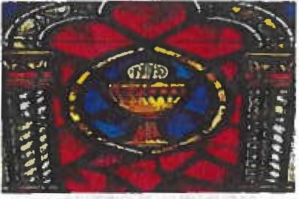

*'Jhe eU/u1a£nte,nntaf wuptake aontinuef*



The znd Annual Yearlong 50*I*50 Raffle tickets slowly trickling in! As of this month our winner will receive

$6,200



e 18atk age of jf ront ages ast

*P.acli montli we wif[ trave( 6ac{ in time everyfive (to ten)years tlirougliout tlie past 150years to reaatlie lieadfines 6otli foca ffy and witliin tlie Cliurclifrom old newspapers. Now fet usgo 6ac{ to....*

From *The Kane &publican* -August 1, 1919

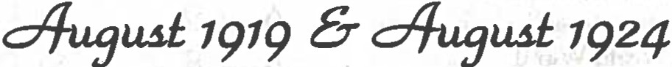

IBROWN T:;:-c;..EA&URING

19 ' INCHES, CAPTURED

'V ELME.. RIDER

1rhe• 1urgest brown trou t that hae

been brought Into Kane this season, waa secured yesterday ifin the Klmma region bv t<:lmer Rider. 5:li Hacker street. The fish measured exuctl)• 19 Inches unrl weighed :ni, t>oundic. The day· cutch netted .Mr. H ider 1:1 t rou t,

I

t he ot herH mmumrlng betweun 10 and

From *The Lake Share Visitor (Erie, PA)* -August 15,1924

13Inches. ,.·

RidaWay

The -Picnic gfven by -the mem bers of St. Leo's Aid society at Meadow brook ch'b last week waa a ve1·y enjoyable eveat. One h u nd red and forty women wero presen t aud t hey s)>en t t he aft­ ernoon In playin g cu rds. Aft.er the su1>per was served dancing and nn l-c was Ind u lged In. A vot e of than ke waa extended to MrA. R. D. Ely and lol rs. Oeorge A. McClain. who assisted In J.he plans tor the ou tin g and clo­ ooted tbe uee of their . homes fpr n1eeU n ga.

'lHElOCAt -PQU E

# TODAYS STOCK MARKET

Quotation• Puml1hed *111* lch111ldt &

w. Balle1, MaHglr,

Brnndette Statue (Q

Be Erected In Lourdes

A subscrli>Uon io erect a statu te to 1

It, BRADFORD COUPLE IJ

D"

f'rank

QuotntlollH nt 2 o'clorlc :

Bernadette a.t

the Lourdes shrJne has 1

t :......., *I*

But the Girl in Iha CaSe_ Mao-

#### aged fo Escape and Has

.\tchln•on US; •:rt.. 18% ; . \". l'.

oll'1; ltf'Ddlng 8M'Jf,; I lll'ln 1'111•, 132%, 'Si1uthf'm l'ac. in% ; ,\nn11conda H'l:

.\ mrrlrnn timelier 8H4 : Ke11nM·olt

10')1; Tennessee Cop11Pr 1;, 1,; l'tah

been opened by Magr. Shoepf er, Bish­

op or Tarbes and 1.A}urdes. The mlr- ·

hnm *:1:,*%; Crucible 1:1;,'lf ; Ooodrh-h

f acle

presented

In connectlQn with

THE PAIR. HAO BEEN TOURING

P'or Two W••k• 11 the tnfonnatlon

urnlahecl tho Pollce Who Hold

tho "Prbtolpale at lhe lnatance

of the Lad'• Pather.

A young n1an and young woman. 7 who motored lnw town In a Ji">rd car lnte > eatcrday aftentoon. Were detain·

ad h)' the local poll"9. at tbe ln•tonee

.lf a Dmdfof!J ntaldonl aAn1ed :rrfewtnaa 1

Who ..taled ihat ho WD8 tbO f&tbor or I

:ho boy. 'k'.\wanl :iio:e.-man, who pve 1 11• uRo a11 IG ye11r1t, but appeured <'OD• I ddffrubl)" older. Tho girl p\'O the 1 "lDlno or Catherine Humltu and her

sso u11 IS rM. but ahe looked to be 1

uuch younger and Maid tha.t ahe bad ,

»een married . Accu in to. the•. In· ,

Ml :· larlnc rre. II : lcxl an l'eto 181l'lfi: llooth fl'lshcrloR :?2%: Ohio CltlPH Ono :.6'11.: Okla. l'ro. toy.:

llt111lohakPr 111!1; l'nn·.\morlrau I U% : ltoynl IJ111< ·h *11:.;* llh1('h•nr Oii GO% : ToxnK Oii 26N !t,; I . II. Steel 110; II.

II. Huhher 12:0% : We•lln11houao t;>j .

Curll.

lloHIOll " \\"yomlllg u;: Wlllr•·Ovur· Jund ;:1P • ; Cnmlt!ll II "1l ; <Hcnrnck ci 1:s. 1al11nt1 Oil ;-,. : lcrrltt on 2a ; lld· WCKl Oil Allll'rlcan ("all 11: Ohio

*= ;*

* uel K111111l y :.1: ,\ merh-un \\'lnow llla11s 1211•,; Kln<·lnlr Gulr :iM; Ohio

•"lu•I Oil 2;•,; \ tlnntl.; l'utn 3!io: !!nit

c·n. •k I'm. *:.11;* I . s. !lten111shl11 ;p';

••ut1un1I • Oii :11,.

## the cnue of beatifica tion *ot* Berna-

. det(e are soon to be examined at

## ! Rome. Bernadette has recen tly been··

t declared venera ble.

• • •

PROTECT THl!t · AMERICAN PEANUT

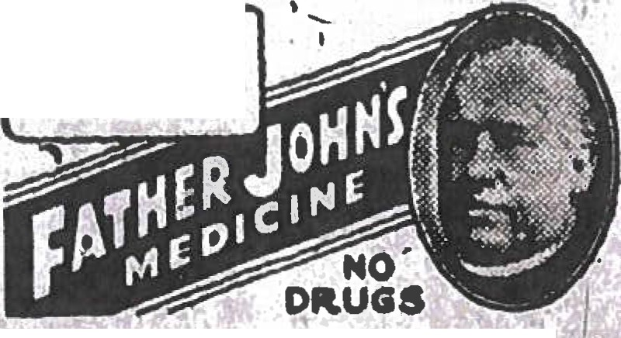

FOi COUGHS

AND COLDS

IJedlelne for )'OU It he doea l'Ot han It lia

,,t.gc.lc.,... Pt'weP•lilcwl mIfae)'noda aMad bll.r.

''Yoar 4nnlat ean nt Father *.i* b

'

tl.lt CO 'Ji ltla..1)WW'lal•

·

The 'Wholo <:oUntry will be .pleo.eo.,

wllb t ha an11ouucen11ent. or t.be l>ep•ri·

••H•nt or AKl"lculturo that the p-nul. t:rop or I.l e Knuth will be a mllllon bu·

.!Shel• larger t.han laRt. year. The eoun· t ry IR ga•o.tl-llocl bylncroaeod produe· Uon nr uny rood crop. part.10nlarly one

that Rer,•eH. In port.. GK a •ubat.ltut.e *to..*

1noat. and unltnala rate. The roa11t.ed t>ennut., peauut. but.t.er. and peanut oU parn1lt u. vnrloty *ot* uses or thla artl­

;: o or dl< t which enable c:onKumerH to

""o It ae o enbattt.ue ror ot.l1er ro<>de

:.hut nuay l.Je f'ou11d relatively 1nore ox- 11cnMl'\•c.

*\*Next month - September 1929 &Septembr 1934*

:mesicmeb. llublisheb. & 3Brinteb bv 1father ustin llatrirk !lino + a«tor ca 2024